BY THE SEA
Brainstorming:

Do you like a sea?
When did you first see a sea?
What memories do you have connected to being at the sea?
What do you usually do on the beach?
Do you like sunbathing?
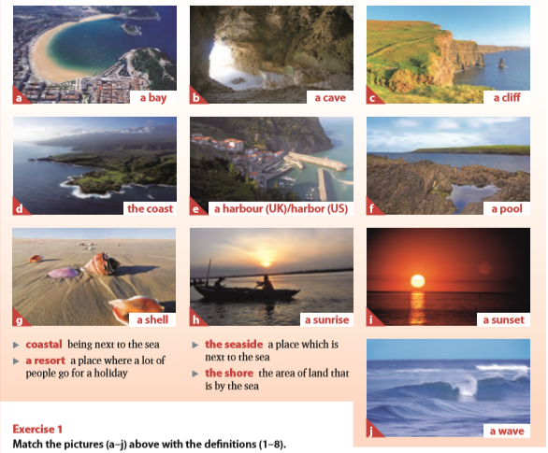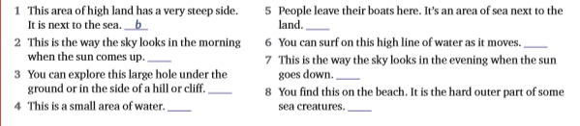

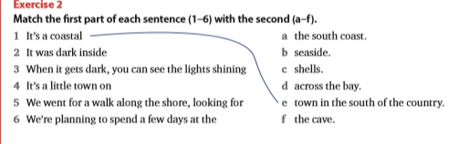

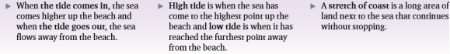
What’s the difference between an ocean and a sea?
Are you an ocean or a mountain person?
What’s the scariest thing about oceans?
How important are oceans and seas?
What are the most beautiful creatures living in the oceans?
What scary monsters live at the very, very bottom of the ocean?
Do you think there should be more ocean than land or more land than ocean?
Are the world’s oceans in danger? How can we protect them?

