BY THE SEA
Brainstorming:

Do you like a sea?
When did you first see a sea?
What memories do you have connected to being at the sea?
What do you usually do on the beach?
Do you like sunbathing?
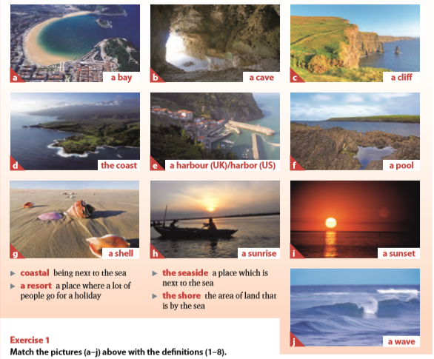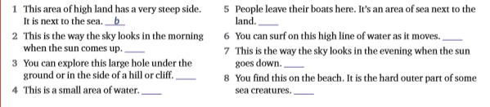

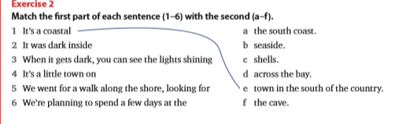

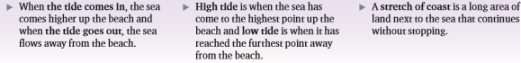
What’s the difference between an ocean and a sea?
Are you an ocean or a mountain person?
What’s the scariest thing about oceans?
How important are oceans and seas?
What are the most beautiful creatures living in the oceans?
What scary monsters live at the very, very bottom of the ocean?
Do you think there should be more ocean than land or more land than ocean?
Are the world’s oceans in danger? How can we protect them?

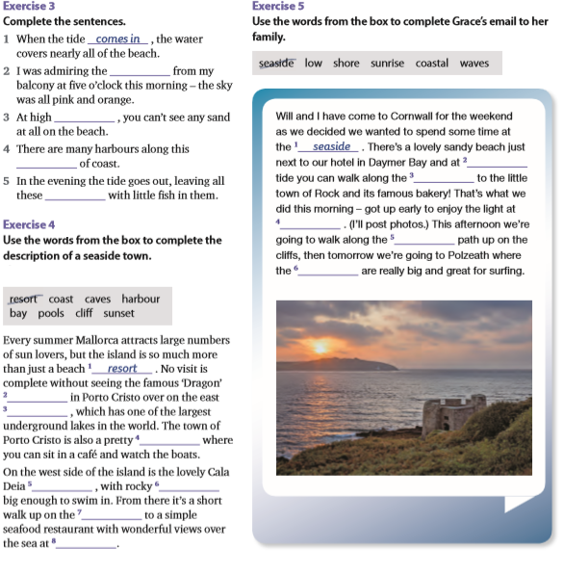

Read the advertisement on the right and fill the gaps using the
words below.
cruise sail dock board
cabin suites liner ports
guides land ruins

2. Bellow are the descriptions of a couple
who took the cruise. Try to think of what
they thought of the cruise and some of
the things that might have happened to
them on the cruise.

Mary Prescott
fell in love with the Greek Islands
when she travelled through them as a college student and has always wanted to go back

wants to get into really close contact with the culture and meet the
people

hates tourist areas, prefers finding places off the beaten track
had never been on a cruise ship
before
Paul Prescott

has been working extremely hard, just wants to relax on his vacation
and enjoy some nice weather

doesn't like hurrying from one hotel to another and trying to deal with people who don't speak English
isn't particularly interested in Greece,
but knows that Mary loves it

likes the idea of spending some time on a ship as it reminds him of his
days in the navy
3. Now listen to a conversation between Paul and Mary. How close were you to what they actually said?

4. Explain the meaning of the underlined parts of the sentence
When in doubt, I follow the crowd. At least I don’t stand out like a fool.
He was getting on my nerves, so I told him to take a hike.
Bad news travels fast.
When I came back, my car was gone. I had locked it and it couldn’t have vanished into thin air.
What are you driving at?
It’s getting dark. I have to hit the road.

WHY WAIT FOR SUMMER TO COME TO YOU WHEN YOU CAN GO TO SUMMER ON A SMOOTH SAILING LUXURY CRUISE OF
THE GREEK ISLANDS
SEA TRAVEL
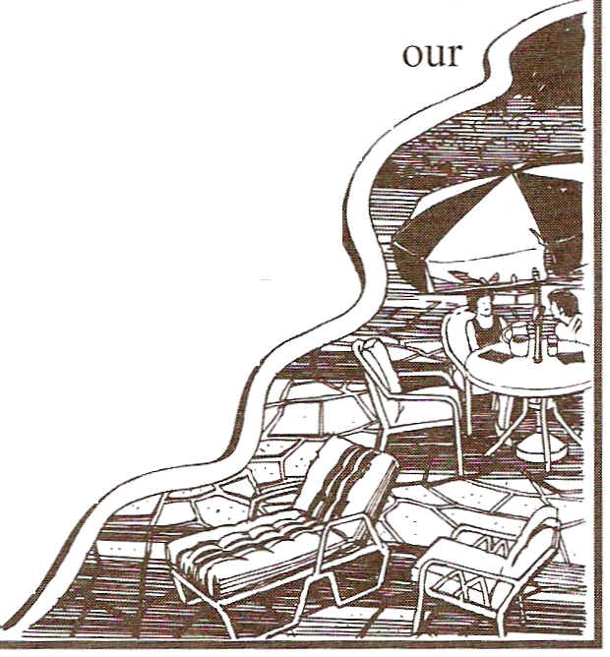
Luxury Cruise Lines' spring season has now begun, and we're kicking the year off with a bang with a special offer on a fabulous
1 round the Greek Islands. Come and 2 _
with us through the beautiful green waters of the Mediterranean, where summer comes a little bit sooner and a whole lot hotter! We'll
3 at 4 on seven beautiful Greek Islands,
where our knowledgeable tour 5 will show you timeless
Greek 6 , romantic wilderness, and exciting cities.

Discover the joy of languishing in a romantic waterfall, or shopping in a small seaside open market.
But not all of the action takes place on 7 ! You'll find
everything you need to feel at home on 8 _

Luxury Cruise Liner. We have a wide range of comfortable accommodation, starting with the economical single or
double 9 and going all the way up to
luxurious 10 . As for entertainment,
each 11 has a fitness centre and several

swimming pools, as well as casinos, bars, and showrooms. So come join the fun,

and sail off into summer!

