**Shower**

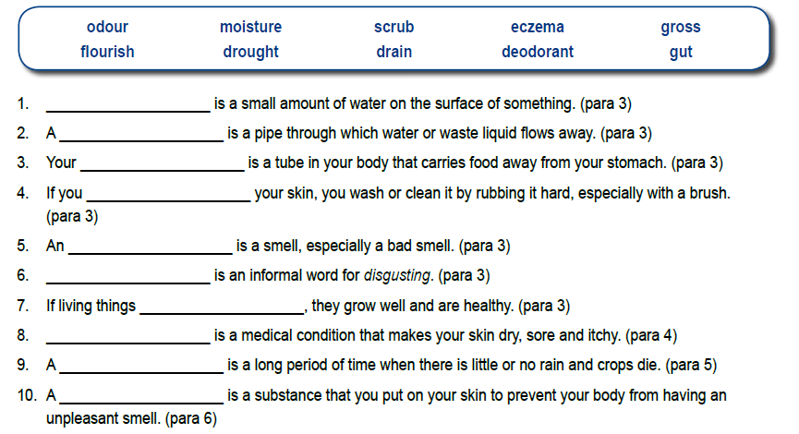



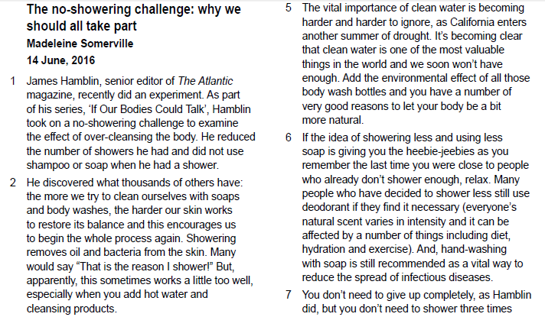

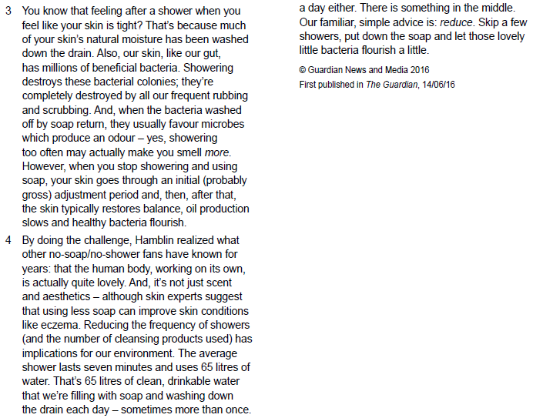

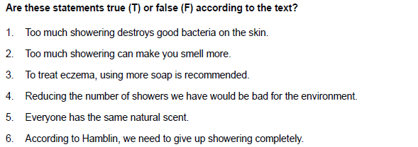

Scientists have found that taking a shower _____________________ for you. New research from the University of Colorado has found there can be _____________________ harmful bacteria in showerheads. Researchers said the very first jets of water from the shower are the most dangerous. The shower acts like an aerosol, spraying the _____________________. This means having a daily shower may _____________________ we think. Scientists tested 50 different showers across nine US cities. They discovered that a third of these had _____________________ bacteria that can cause lung damage. Researcher Laura Baumgartner advised: “For most people, the answer is simple. Don’t stand in front of the shower _____________________ comes out."

The research _____________________ project that is looking at our daily environment. In particular, the research team is looking _____________________ of water and air in schools, homes and public buildings. Research into the bathroom environment _____________________. Ms. Baumgartner said showers were more dangerous than baths because _____________________ sprays. Showerheads are much harder to clean than baths because they are enclosed. Furthermore, it _____________________ inhale the bacteria into our lungs because of the steam in the shower. Baumgartner did say we should _____________________ about her discovery: "I take showers every day, and I’m not at all worried," she said.