**STUFF**

What objects do you use every day?

What is your favourite everyday thing?

Which thing do you think you use most often?

What would your life be without it?

**Match:**

a small thing on the floor outside your house where you clean your shoes radiator

a portable, foldable table with heat resistence surface for doing a specific chore hanger

a metal or wodden thing you use when you put your dress or suit in the wardrobe slippers

the cloth which people put on their floor to make the room warmer door handle

you must touch it if you need light in a room crutches

a large metal object used for heating rooms scales

a tool used for making holes in wood or teeth door mat

you need these to walk if you have a broken leg carpet

an attached object or mechanism used to manually open or close a door switch

you wear them on you feet when you are at home ironing board

you use these to weigh things dril

**Complete the sentences:**

If you want to smoke, you'll have to use matches. I left my __________ in the car.

I need ____________ when I want to open a bottle of wine.

I’m looking for ____________ when I want to clean between my teeth.

The Chinese use _____________ to pick up food.

Hold the_____________ when you go down the stairs. They are very steep.

If you want to smoke, you'll have to go outside; I don't have an ___________ for your cigarette ends.

I want to hang this picture on the wall. Do you know where the ______________ is?

Pull the plug out of the ______________. The phone battery is full again.

Do you have a _______________? My shoes are hard to put on without it.

After you have taken a shower you need a brush or a __________ to make your hair tidy.

**How to speak about things when you don’t know what they are called.**

* *It’s long and thin… (shape - ________________________________________)*
* *It looks like …. (similar to)*
* *They are made of… (material - ______________________________________)*
* *It’s used for… (purpose-_______________________________________)*
* *It’s something you use when …. (situation)*
* *It has got …*

Do you see yourself surrounded by many items you do not really need? Could you lead a simpler life?

**Listening: How to declutter our lives?**

What did Alice do at the weekend?

What happened why she was tidying up her wardrobe?

How many pairs of shoes does Rob have?

Why does she have so many shoes?

Why does Rob have so many plastic bags?

What is the “three bucket system” about?

Where is B. Johnson from?

What thing did she even consider getting rid of?

Does Alice buy labeled goods?

What is Rob proud of?

What things are important to Alice?

What is materialism?

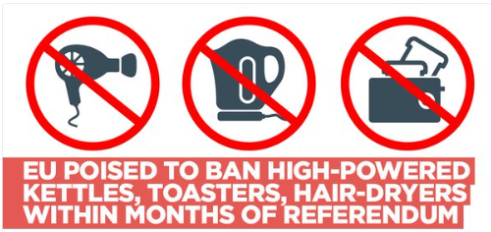

The EU looks set to ban certain high-powered kettles and toasters shortly after June’s referendum in a move that has been described as an “assault” on the staple(hlavní, základní) British breakfast of tea and toast.

European Commission President Jean-Claude Juncker revealed the decision to push ahead with the plans soon after the Brexit referendum on June 23, despite some senior EU officials warning the move would bring “ridicule.”(posměch, výsměch)

The plans were prepared by Brussels months ago, but were shelved (odloženy) over fears they could be seen as an attack on Britain and influence the outcome of the referendum.

Internet routers, hair and hand-dryers, mobile phones and patio jet-washers are also being examined by Commission experts as part of a wider strategy to dramatically cut energy use in the home.

Some products deemed eco-friendly might be allowed to stay, as officials admitted the plans could incite (podněcovat) public anger at perceived meddling (vměšování) by Brussels.

EU Commissioners admitted they need to take a “diplomatic” approach when choosing which items to regulate due to the "sensitivity surrounding certain products.”

They must “take into consideration the criticisms leveled at the EU, which was seen as intruding too much into citizens' daily lives."

What is your opinion of this regulation?

Which of the three things would be the biggest loss?

What is the reason for this regulation?