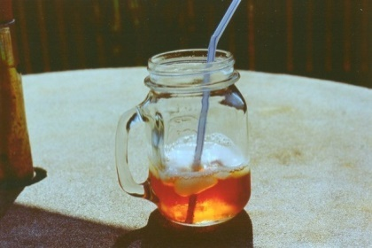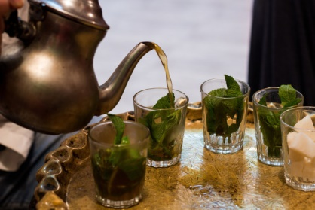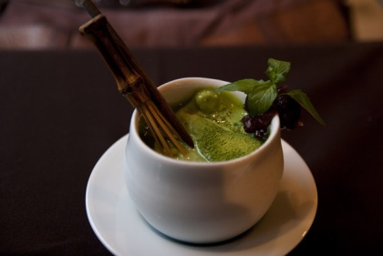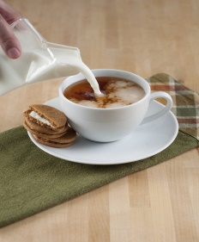

Where can you drink the tea in the pictures?

Have you ever been to these countries? Did you drink tea when you were there?

**Vocabulary**: tea pot, tea bag, tea leaves, loose leaf tea, spoon, mug, cup, brew

**Idioms – match:**

If we don’t like something very much, we say… **It is as good as a chocolate teapot.**

If there is something you would never do, you say **… You make a storm in a teapot.**

If something is completely useless, you say… **It is weak tea**.

If you react too angrily over a small matter … **It isn’t my cup of tea.**

If something is unimpressive, we say … **I wouldn’t do it for all the tea in China**.

**What do you think of the following sentences?**

I can’t imagine my day without a cup of tea.

I think I can make really good tea.

I don’t know anybody who doesn’t like tea.

Tea is not very good for your health.

Black tea stains your teeth.

My tea must be really sweet.

**Green Tea**

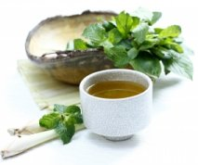There are over 2,000 different kinds of tea in the world. This huge number of teas can be divided into five categories: green tea, black tea, white tea, oolong tea and herbal tea. All these types of tea come from the same plant, camellia sinensis. Different teas are made by doing different things to the leaves of the camellia sinensis plant.

A variety of tea that has recently grown in popularity worldwide is green tea. There are several reasons why green tea has become popular. It has less caffeine that black tea and has a nicer flavour. But the most likely reason green tea has increased in popularity is the fact that many people think that drinking green tea is good for your health.

Green tea was first drunk in China more than 4,000 years ago and it still enjoys popularity there today. There are many different kinds of green tea in China. Each province, or area, of China produces different kinds of teas. The most famous Chinese tea, called Longjing tea, comes from Zhejiang Province. Fujian Province is also famous for growing tea. This area of China has a very good climate for growing tea and there are many famous kinds of tea that come from there.

China isn't the only country to have tea drinking traditions. Japan, Korea, Vietnam, Thailand and many other Asian countries produce and drink green tea and have done so for thousands of years. Japan has an especially rich green tea culture. Like China, there are different areas of Japan that are famous for different kinds of tea. Some people think the best Japanese green tea comes from the Yame region.

People have felt for a long time that green tea has positive effects on our health. Recently, many studies have been done to try to prove these claims. These studies have shown that green tea can reduce heart disease, some kinds of cancer and improve brain functioning. But these studies have only been done on animals. There have also been many studies on green tea's effects of humans. Scientists have studied green tea's effect on weight loss, cancer, heart disease, Parkinson's disease and glaucoma. The results of these studies have shown that green tea might help in treating or preventing these diseases. More research needs to be done to prove completely that green tea can or can't help in treating these diseases.

Whether you believe that it can cure all your ills or not, green tea is very popular now and will most likely continue to be popular in the future.

**Reading comprehension:**

What does the author think about green tea?

What is one reason why green tea has become popular recently?

What is true about green tea in China?

What is true about green tea in Japan?

Green tea can prevent and cure many diseases. True/false/not given

Green tea is very popular now and will most likely continue to be popular in the future. Fact/opinion

________ in every part of the world

________- part of your body that controls what you think and feel.

________-the weather in a place

________- medicine or treatment that makes someone healthy after they have been sick.

**Conversation:**

What brand of tea do you like?

How often do you buy tea?

Do you like tea rooms? How often do you go there?

Do you like drinking tea in restaurants and cafés?

Is a box of tea a good present? Do you like getting tea?

Do you think tea is expensive?

What do you know about Boston Tea Party (1773)?

Do you know anything about how tea is grown or made?

What do you know about the conditions of people who work on tea plantations?

**Video: How to make tea the British way?**

Why don’t the British drink iced tea?

What are the rules about milk and tea?

What is the most popular tea in Britain?

What is Builder’s Brew?

What is White Without?

What is dunking?