ALL KINDS OF TESTING - CONVERSATION :o)

What images spring to mind when you hear the word ‘test’?
Do you like taking tests?
Are you good at taking tests?
What was the last English test that you took like?
Would you be more nervous before your driving test, a blood test or an English test?
What’s the best way to prepare for a test?
What was the worst test you ever took?
Are there too many tests in school?
How do you feel when you fail a test?
Are there any kinds of tests that you love?
Do you have any special routines you follow before you take a test?
What do you think about while you wait for the result of a test?
Have you ever cheated on a test?
Have you ever taken an IQ test?
Do you think testing is useful or a waste of time?
Do you think your test scores reflect your true ability and intelligence?

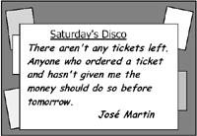
Look at the text in each sign. What does it say?Choose the correct answer.
a)It is possible to reserve a disco ticket if you do so by tomorrow.
b)Reserved tickets for the disco must be paid for today.
c)Tickets for the disco can be collected after tomorrow.

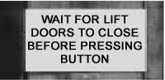
a)Press the button after the doors close.
b)Press the button to close the lift doors.
c)Press the button while the doors are closing

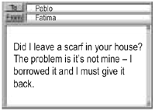
What does Fatima want Pablo to do?
a)lend her a scarf
b) look for the borrowed scarf
c)return the scarf he borrowed

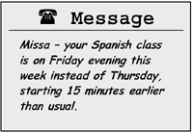
Missa's Spanish class
a)will be a day later than normal
b)will no longer be on Thursday
c)will not be in the evening this week

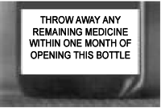
a)This bottle contains enough medicine for one month.
b)Unopened bottles of medicine must be thrown away within one month.
c)You can use this medicine up to one month after opening it.

Exploring the Arctic
The Arctic is one of the few places in the world untouched by pollution where you can see nature at its wildest and most beautiful. Join our ship the Northern Star from 2 to 18 July, for a 17-day voyage to the Arctic. During the voyage you are able to relax and get away from it all. There are no parties or film-shows to attend, quizzes to enter, or entertainers to watch. However, we do have specialists on board who are willing to answer any of your questions about the Arctic and who will talk about the animals and birds that you see on the trip.
After setting off from Scotland, we go north along the coast of Norway to Bear island. Along the way you'll see thousands of seabirds and wonderful scenery, with rivers of ice and huge cliffs. You will have the chance to see reindeer, polar bears, and other Arctic animals. Although we have a timetable, experience has shown that we may have to change our direction a little, depending on the weather and on which animals appear.
The Northern Star is a very special ship and our past voyages have been very popular. Our cabins all have the same excellent facilities, which include a private bathroom and refrigerator. Our chefs are happy to prepare any food for people on special diets. Choose just what you want to eat from the wide variety available from the dining room buffet. There is a library, shop, clinic and plenty of space for relaxation. lf you need some exercise, why not go jogging every morning around the decks, or do some swimming in the indoor pool.
Prices include economy class air travel and 16 nights on board the Northern Star, all meals and excursions and all lectures.
Day 1
Board the Northem Star
Days 2-7
We sail slowly north along the coast of Norway, stopping at places of interest.
Day 8
Tromsø. You need to get up at sunrise to see the whales as we sail towards Tromsø. Visit Tromsø to see the Arctic Museum, the cathedral and the beautiful old wooden houses. In the evening we sail away along the west coast to Bird Island, which is excellent for bird-watching.
Days 9-10
Bear Island. We arrive here in the early evening and stay overnight. Bear Island once had an active fishing industry, but today little of this remains. We will explore the island, looking out for Arctic flowers.
Days 11-16
Spitsbergen. A place of mountains and rivers of ice, it is home to a large variety of animals.
Day 17
Leave the ship in Spitsbergen and fly to London from Tromsø.
Now answer whether these statements are CORRECT or INCORRECT:
- This trip is for people who like peace and quiet.
- Many different activities are organised on board.
- The voyage begins in Scotland.
- The ship follows a fixed route.
- There are different types of accommodation.
- Passengers serve themselves in the dining room.
- Whales can be seen in the morning near Tromsø.
- There are some examples of traditional buildings in Tromsø.
- The ship stays overnight in Tromsø.
- Bear Island used to be a busy fishing centre.
LISTENING:
1.What does the man receive in the post? 
2.What did the man buy? 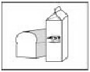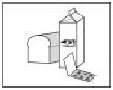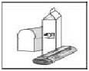
3.How can people travel today? 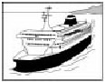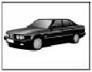
4.What is the date of the wedding anniversary? 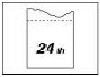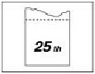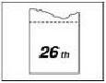
5.What musical instruments does the family have now? 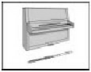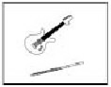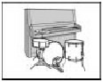
6.What's the weather like in the mountains? 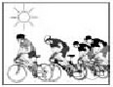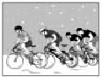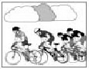
7.How did the woman learn about the fire? 
LISTENING: You will hear a tour guide talking to some new guests at their hotel.
Fill in the missing information.
Tour Guide
The office is_____________the reception desk.
Meals
Breakfast:in the Green Room on the first floor beside the lifts.
Food for trips: collect from the____________at 9.00 a.m.
Dinner: hotel restaurant famous for its_____________dishes.
Riverboat Trip
Day:____________________
Time: afternoon and evening
Cost of Holiday
Everything is included except_______________.
Facilities
It's possible to swim from_____________a.m. untill 10.00 p.m.

