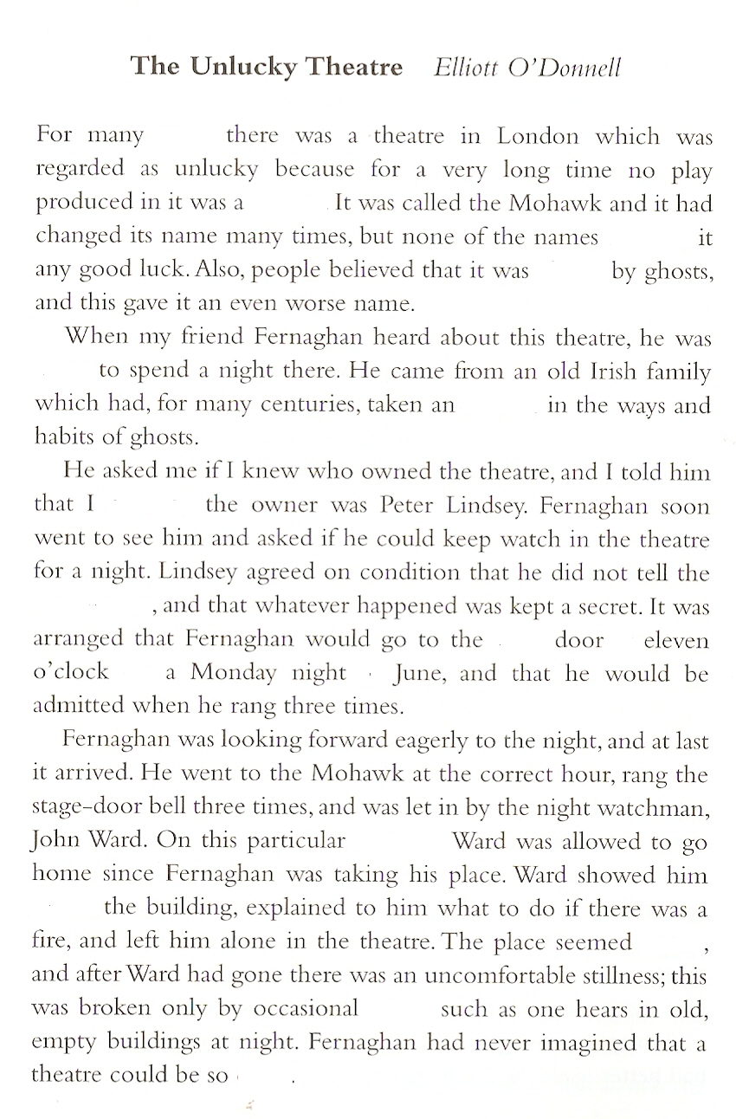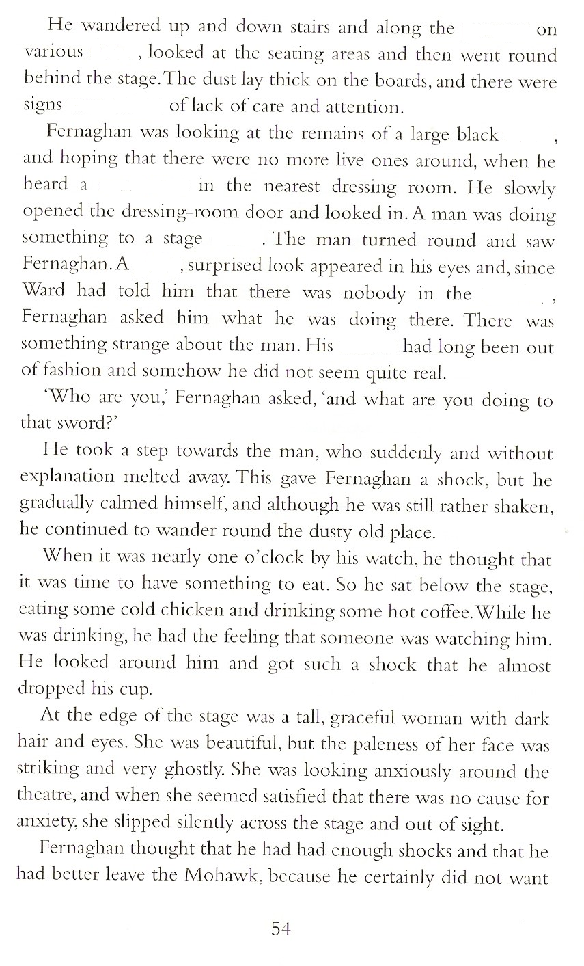

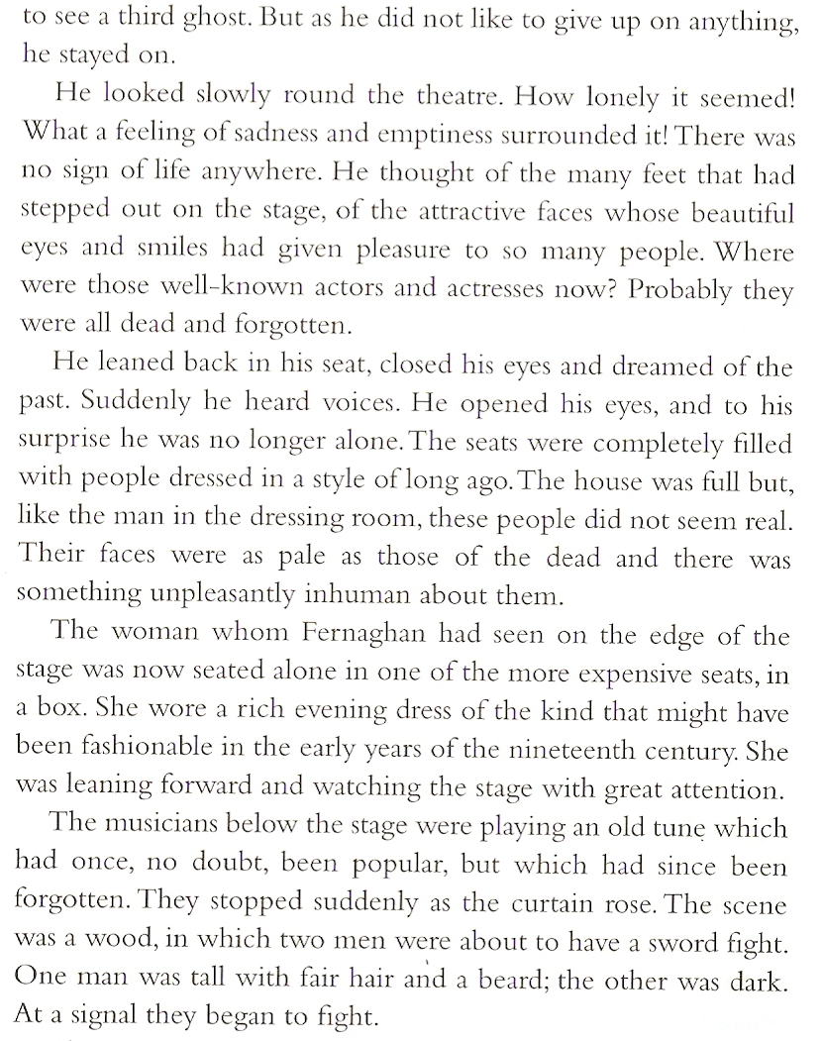

**Listening: Part 3 Answer the questions:**

What did the lady in the box look like?

Who killed whom?

What did the audience look like?

What did Fernaghan do after the performance?

When did the story happen?

What was the play called?

Why did the murder happen?

How did it happen?

What happened to Ross?

What happened to the theatre after the murder?

What did Mr. Lindsey do with the theatre?

