**THEATRE**

**Vocabulary:**

rehearsal

front row seats

season ticket holders

matinee

a play

a tragedy

a comedy

a playwright

a role

a part

a plot

acts

scenes

premiere

perform on stage

a performance

clap

character

a female character

a male character

a villain

audience

setting – scenery

props

costumes

the stage

a curtain

**World Theatre Day** was created in 1961 by the International Theatre Institute. It is celebrated every year on March 27 by theatre companies around the world. Theatre groups of all kinds put on special performances and events to mark the day. The most important event is the message given by a leading figure in world theatre. The first message was given by the French poet, novelist and film maker Jean Cocteau. World Theatre Day is also an occasion for actors, playwrights and directors to celebrate the power of the performing arts and how they bring people together. It is also a good chance for artists to show the world how theatre can and does create peace between people.

Theatre is one of the oldest performing arts. It dates back thousands of years. It has its roots in story- telling and evolved into acting and the stage. The word ‘theatre’ comes from the Greek ‘theatron’, which means "the seeing place". Theatre forms a rich part of every culture, from ancient Greek tragedies and Japanese Kabuki, to Indian Sanskrit epics and the medieval world of Islamic puppet theatre. Today theatre is enjoyed by millions of theatre-goers around the world. People have a huge choice of dramas, musicals and comedy theatre. They can enjoy watching the top actors on Broadway or London’s West End, or simply watch their local amateur dramatics production.

**Write down three questions based on the article:**

1.

2.

3.

**Can you match the playwrights and their plays? Have you seen them? What do you know about the playwrights?**

William Shakespeare Waiting for Godot

Anton Chekhov Les Misérables

Oscar Wilde The Misanthrope

Samuel Beckett Much Ado about Nothing

Tennessee Williams Three Sisters

George Bernard Show Cat on a Hot Tin Roof

Moliere Pygmalion

Victor Hugo The Importance of Being Earnest

Do you use the British spelling ‘theatre’ or the American spelling ‘theater’? Does it matter which one you use?

How often do you go to the theatre?

Is the theatre only for rich people?

What do you like and dislike about the theatre?

What’s the best thing you’ve ever seen at the theatre?

Would you like to work as a theatre critic?

Are theatre tickets easy to get in your country?

How do you feel when you sit in a theatre before the performance begins?

What’s the nicest theatre you’ve ever been to?

Why is the theatre important?

What kind of theatre history does your country have?

Do you prefer watching a play at the theatre or a movie at the movie theatre (cinema)?

Have you ever been to the theatre in another country?

Do you think people will always be interested in the theatre?

What questions would you like to ask a theatre actor?

Would you like to perform or act on stage at the theatre?

Would you like to see a theatre play in English?

**Listening:**

When I was growing up, I always __________________ was for rich people. I __________________ it is. Theatre tickets in London are pretty expensive, especially for a whole family. But __________________, I found you could go to the theatre __________________. I found dozens of smaller theatres in London that had very reasonable prices. You could __________________ tickets for the big theatres. Going to the theatre is a wonderful experience. It’s great sitting in your seat with your programme. I __________________ the set will look like. I’m always impressed by the quality of acting. Actors __________________. They stand on stage in front of an audience of hundreds, and __________________ confident.

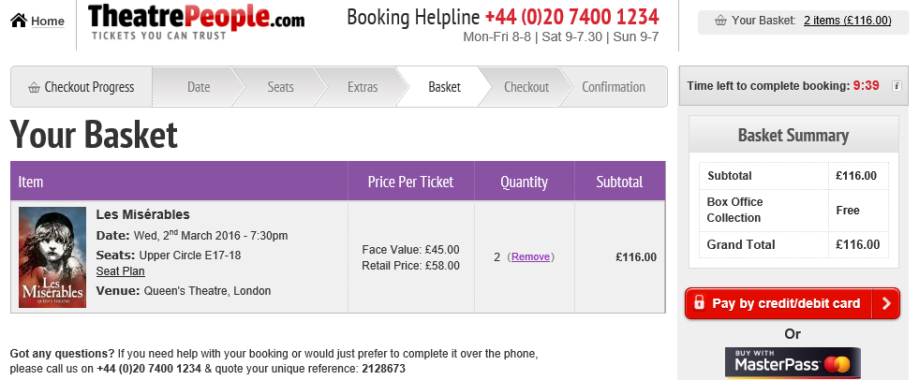

[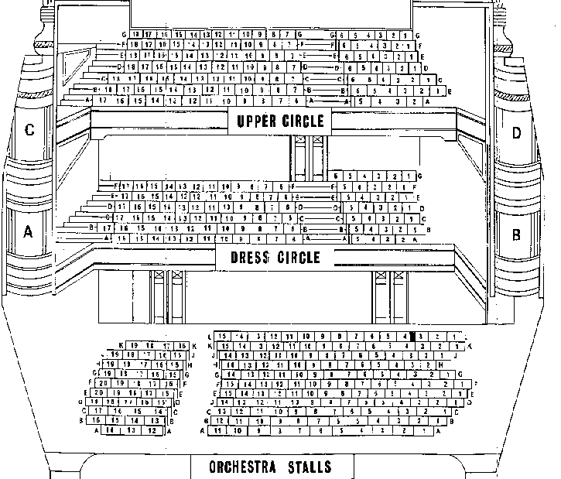](http://www.google.cz/url?sa=i&rct=j&q=&esrc=s&source=images&cd=&cad=rja&uact=8&ved=0ahUKEwiWmfKN1qHLAhVEvxQKHR7nCI8QjRwIBw&url=http://www.londontheatre.co.uk/londontheatre/seatingplans/fortune.htm&psig=AFQjCNHTyixov6LABrMr8sadi_fKMerDow&ust=1456996770774229)