To Ban or not to Ban

- can’t (more informal)
- mustn’t (more formal)
- be not allowed (both)
- be not permitted (more formal)
- be banned (more formal)
- be forbidden
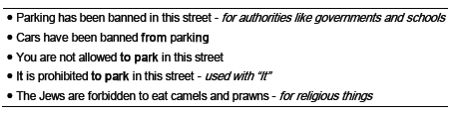
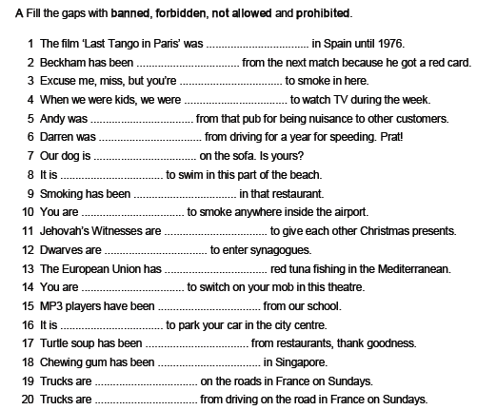
South Korea 'bans' miniskirts
A new law has come into force in South Korea that effectively bans the wearing of miniskirts. The controversial piece of legislation is called the "overexposure law" and is an attempt by the government to curb (omezit) what it views as public indecency. Anyone caught wearing a miniskirt could be fined around $45. It is one of the first laws to be passed by new president Park Geunhye and has come under considerable criticism.
Her father, Park Chung-hee, who led the country between 1963 and 1979, introduced a similar decree (výnos) on the appropriateness of what Korean women could and couldn't wear. A spokesperson from South Korea's police said the law is more concerned with public nudity than provocative clothing.
Celebrities and politicians are up in arms over the new law. Democratic United Party member Ki Sik Kim wrote on Twitter: "Why does the state interfere with how citizens dress? Park Geun-hye's government gives cause for concern that we are returning to the era when hair length and skirt length were regulated." Many female celebrities have posted photos of themselves in skimpy (skrovný) clothing online to make their feelings against the law known. Short skirts and shorts are extremely popular in South Korea. They are the fashion items of choice for the majority of the country's pop stars. Singer and fashion icon Lee Hyori tweeted: "Is the overexposure fine for real? I'm so dead."

Banning Pitbulls
In October, 2004, the province of Ontario, Canada announced that it plans to ban pit bull dogs. According to the new law, it will be illegal to own, buy, sell, breed, or import this kind of dog. The new law will allow people who currently own pit bulls to keep their dogs, but only under very strict rules. These dogs will have to be muzzled (s náhubkem) and on leashes. New ownership will be completely banned throughout the province. The law will also place severe restrictions and penalties on irresponsible owners of all breeds. Dog owners who break the new law may have to pay fines of $10,000 or spend up to six months in jail.
A number of very serious pit bull attacks in Ontario caused the government to take this action. In one situation a man was attacked by two pit bulls and it was necessary for the police to fire over a dozen bullets before the attack stopped. According to Michael Bryant, the Attorney General of Ontario, the man was “practically eaten alive from the ankles up”. In another recent case, a three-year-old child needed over 200 stitches to close the wounds he suffered in a pit bull attack. Before reaching its decision to ban pit bulls, the Ontario government spent several months meeting with different groups on opposite sides of the debate. Since the government made its announcement, there has been mixed reaction among the people of Ontario. Many people are delighted with the new law. However, pit bull owners as well as many other dog owners are not happy. They believe that the problem is not the breed of dog. They think that dogs only become vicious (zlý) when they have irresponsible owners.
While Ontario will be the first province in Canada to ban pit bulls, some cities have already done so. In 1990, Winnipeg, Manitoba became the first Canadian city to ban pit bulls. According to a Winnipeg city official, the number of pit bull attacks has decreased from 29 in 1989 to zero this year. There are similar bans in France, Britain, and Germany.
According to some studies that were done in the United States, pit bulls make up only one to three percent of the overall dog population, but they cause more than fifty percent of all serious dog attacks.
New York mayor proposes ban on big sugary drinks The Mayor of New York, Michael Bloomberg, is calling for a municipal ban on sales of super-sized sugary drinks in an attempt to tackle (vypořádat se) obesity. He wants to stop the city's restaurants, delis, sports stadiums and cinemas from selling large sizes of sweetened soft drinks. Research suggests that 58% of adults in New York are obese or overweight. The New York City Beverage Association said the measures, which could come into effect next year, were "zealous" (horlivý). "The city is not going to address the obesity issue by attacking soda [sweetened soft drinks] because soda is not driving the obesity rates," spokesman Stefan Friedman said in a statement. But officials at Mayor Bloomberg's office at City Hall disagree. Citing a 2006 study, they argue that sugary drinks are the biggest factor in rising calorie consumption and obesity levels.On its website, the New York City Department of Health describes how drinking one 20-ounce (590ml) sweetened soft drink a day translates into eating 50 pounds (22.6kg) of sugar a year. Under the proposals, any bottles of sugary drinks larger than 16 ounces would be taken out of the refigerators in cafes while extra-large options will disappear from restaurant menus. The ban applies only to drinks that contain more than 25 calories per 8 ounces. The proposed law on sweetened drinks is the latest in a long line of public health interventions by Mayor Bloomberg's office. During his three terms in office, he has banned smoking in the city, outlawed trans-fats in restaurants and forced chain restaurants to put calorie-counts on menus. His zeal for taking steps to make New York a healthier place has earned the mayor the title "Nanny Bloomberg" among his detractors (kritici). The proposals on sugary soft drinks will go to New York's Board of Health in June for a final decision.
What would you like to ban and why? Rank these and share your rankings with your partner. Put the best at the top.
- miniskirts  - chewing gum  - music players in public  - children in restaurants  - sodas | - kissing in public  - mobile phones in cinemas  - drunkenness  - dangerous dogs  - other _______________

1. Are there a lot of bans in our country?
2. Why are there bans? Do we need them?
3. What ban do you think is the most stupid in our country?
4. Do you think it's OK to spank your children when they do something wrong or do you believe that you should never put your hands on children in order to discipline them? Should spanking be banned?
5. Some parents discipline their children by grounding them when they do something wrong. This is when a child/teenager is not allowed to leave the house and partake in outdoor activities for a specified amount of time. Do you think it is a good idea?
6. Do you agree with corporal punishment? This is when authority figures are allowed to hit others in schools, prisons etc.
7. Are there tobacco and/or smoking bans in our country?
8. What is your opinion on littering ban? Is there any in our country?

HW: Fill in the gaps with the most suitable words from the articles
1. He drove through a red light and had to pay a $100 ___________________ .
2. When I cut my hand, I had to go to the hospital to get _________________ .
3. I want to take the dog for a walk but first I must find the _______________ .
4. Do you think the government should _______________________ smoking in all public places?
5. He was _______________________ when he learned that he had won the lottery.
Write an essey on BANS.

