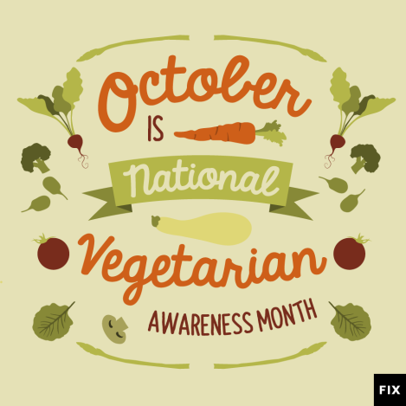**TO EAT MEAT OR NOT TO EAT MEAT**

Vegetarians are celebrating! October 1st is World Vegetarian Day, starting Vegetarian Awareness Month, with World Vegan Day rounding out the month on the first of November.

Vegetarian Awareness Month was established by the North American Vegetarian Society in 1977. You can make a difference this October by telling your friends and family about the benefits of vegetarianism, and encouraging them to try out a vegetarian diet, which can have health advantages.

Vegetarians typically do not eat meat, poultry, fish, or the flesh of any animal. Vegetarianism can also extend to not eating various animal by-products.

|  |  |
| --- | --- |
| **MEAT** | **VEGETABLE** |
|  |  |

**Make questions and answer:**

did last you eat when meat ? _______________________________________________

often meat you how do eat? ________________________________________________

like you salami do bacon or? ________________________________________________

imagine can meat without you your life? _______________________________________

would what miss you most? _________________________________________________

become why people do vegetarians? ___________________________________________

know do vegetarian who you is a anybody? ______________________________________

ever been you restaurant a vegetarian to have? _________________________________

**Listening:** If ____________________ was a vegetarian, I think the world would be a better place. There ____________________ land any more for cows and sheep to feed on. We are ____________________ forests because farmers want more ____________________ so we can eat beef. Vegetarianism is one way to help the Earth. It’s also one way to help ourselves. So ____________________ because we eat too much meat. If we were all vegetarian, we would ____________________. We all need to eat more vegetables. That’s the easiest way of ____________________ health. If we were all vegetarian, we would also save lots of money on healthcare. We wouldn’t have all the ____________________ you get with eating meat. I wonder if we can all stop eating meat.

Step 1 : Complete the questions with the correct question words.

Step 2 : Interview a friend using your questions. Record the answers.

Step 3 : Tell the class some things about the person you interviewed.

Step 4 : Write a paragraph about the person you interviewed.

1. What time do you arrive …… work in the morning?

a. at

b. in

c. to

d. from

2. How do you usually get ………… work?

a. at

b. in

c. to

d. from

3. What time do you usually get home ………work?

a. at

b. in

c. to

d. from

4. When was the last time you went ……… the doctor’s?

a. at

b. in

c. to

d. from

5. Have you ever been ……… an amusement park?

a. at

b. in

c. on

d. to

9. Do you like travelling ……… bus? Why (not)?

a. by

b. in

c. on

d. with

13. What would you do if you were stuck ……… an island?

a. at

b. in

c. on

d. under

17. What’s your favourite pastime …… summer?

a. in

b. on

c. for

d. from

6. What animals have you seen ……… the zoo? Name 10.

a. at

b. on

c. to

d. from

7. What do you usually do ……… your birthday?

a. at

b. on

c. in

d. to

8. Does the temperature ever go ……… zero in Czechia?

a. at

b. to

c. below

d. under

10. Where were you ……… 1/1/2016

a. at

b. in

c. on

d. to

11. What’s the weather like ……… July?

a. at

b. in

c. on

d. to

12. Do children ……… 1 metre ride for free on the bus?

a. at

b. with

c. from

d. under

14. How far is the airport ……… the city centre?

a. at

b. from

c. to

d. in

15. What would you do if you were stuck ……… a lift?

a. at

b. in

c. on

d. under

16. What natural disasters happened ……… 1997?

a. at

b. in

c. on

d. to

18. What do you usually do ……… the evening?

a. at

b. in

c. on

d. for

19. What time do you go to bed ……… Saturday?

a. at

b. in

c. on

d. to

20. Can you name 3 animals that are active ……… night?

a. at

b. in

c. on

d. to

