COUNTABLE UNCOUNTABLE
- lze vyjádřit kusy a pen/ pens/two pens - nelze vyjádřit kusy -1 celek, hmota, směs
- jednotné i množné číslo (-s) - pouze tvar jednotného čísla – IS!
- ! man x men_________
- členy a/an, the - bez členu
- ot. na množství MANY - ot. na množství MUCH
- ___________________ - TEKUTINY: tea, juice, water, oil…
- ___________________ __________________________________
- ___________________ - SMĚSI: salt, pepper, sugar, flour…
- ___________________ __________________________________
- ___________________ - rice, bread, meat, cheese…
- ___________________ !!! homework, luggage/baggage, money,
- ___________________ furniture, hair, fis

- Rozdělte potraviny podle countable –C, uncountable – UN a napište jejich názvy:
1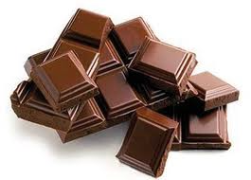2 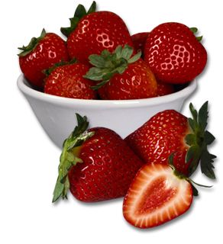3 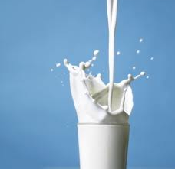
4 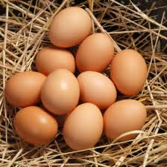 5 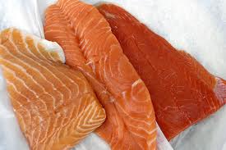 6 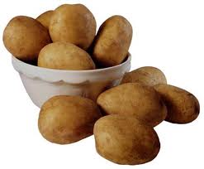
7 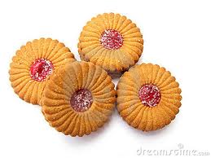 8 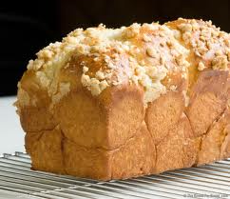 9 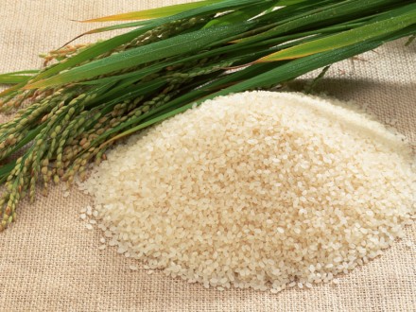

1.___________________ 2. ___________________
3.___________________ 4.____________________
5.___________________ 6.____________________
7. __________________ 8.____________________
9.___________________

- Napište 9 vět, které z výše zmíněných potravin máte, nebo nemáte rádi.
1._I like________________________________________________________
2._I don´t like___________________________________________________
3._____________________________________________________________
4._____________________________________________________________
5._____________________________________________________________
6._____________________________________________________________
7._____________________________________________________________
8._____________________________________________________________
9._____________________________________________________________

ANY v ?, -, SOME v + bez ohledu na (ne)počitatelnost

? Do you have any oranges?
? Do you have any juice?
- I don´t have any oranges.
- I don´t have any juice.
+ I have some oranges.
+ I have some juice.
MANY U POČITATELNÝCH PODST.JM.:
Do you have many oranges?
MUCH U NEPOČITATELNÝCH PODST.JM.:
Do you have much juice?

- Vytvořte otázku k odpovědi dle obrázků.
Picture no 5: _______________________________? There isn´t much. Only three pieces.
Picture no 6:________________________________? Yes, there are some.
Picture no 7:________________________________? There are four biscuits.
Picture no 4:________________________________? There are ten eggs.
Picture no 9: ________________________________? There isn´t much. Only a small pile.
Picture no 2:__________________________cherries? Yes/No,_________________.
Picture no 1:__________________________white chocolate? Yes/No, only_____________.

- Opravte chyby ve větách.
- Do you take some toasts for a snack to work?
- I don´t have many money on me, I forgot my purse with all my money in it at home.
- Yes, I have any French friends but I don´t know any Germans.
- Did you get some homework yesterday? No, we didn´t get some.
- Does your grandfather like any exotic food or does he like only traditional ones? Yes, he likes any Chinese but any too spicy he dislikes.
- Do you have some more questions?

!!! Nepočitatelná podstatná jména se za určitých podmínek mohou objevit se členem, tj. v jednotném, či v množném čísle. V případě, že je k nepočitatelnému podst. jménu dodáno slovo, které počítat lze. Viz příklady:
a tea jelikož se myslí A (=ONE) CUP of tea
a beer jelikož se myslí A GLASS of beer
two (CUPS of) teas, two (bottles of) burs

ale: I like beer. I like tea. Obecné určení toho, co máte rádi, nemluvíte o množství.

- Upravte/ doplňte, co třeba:
- Customers at the table seven ordered five ____________ (tea).
- (At a bar, to a waiter) Excuse me, __________(beer) please.
- I normally don´t buy chocolate at all but I bought_____lovely______ (chocolate) and a card for my granny for the Mother´s day.
- A: Do you like _________ (fish)? B: I did when I was a child but I hate______now.
- What do you prefer with you pork? _______ (rice) or_______ (pasta)?

Zdvořilé otázky Co bys rád=WOULD YOU LIKE…? Vs mám rád I LIKE
I would like (to – když následuje sloveso)= I´d like (to)

I would like a wine. = I would like to order a wine. (Dal bych si/objednal bych si víno)
What would you like to eat/ to drink? (Co bys chtěl k jídlu/ pití?)
Would you like A/SOME* drink/ food? (Dáš si nějaké pití/jídlo?)
* U vět vyjadřujících nabídku je v otázce SOME, nikoliv any jako u zbylých otázek!!!
Yes, please, I would. X No, thank you, I wouldn´t.

Neplést s větami typu What do you like?
Do you like black or white coffee to drink?
Do you like skiing?
Yes, I do. X No, I don´t.

- Najdi a pospojuj otázky s odpověďmi.
- What would you like to do today?
- Does your neighbour like your new dog?
- Is there any clean glass in the cupboard that I can have?
- Would you like to have mayo with your tuna salad, Sir?
- Would he mind to help us with the shopping?
- What does he like doing in the evenings?

- No, he wouldn´t.
- Yes, many! Have a look again!
- No, he doesn´t but he doesn´t mind him too.
- Yes, plenty please! I love it!
- Many things, he has many hobbies, you know him!
- I´d like to go to an art gallery.

Write 5 sentences what you would like to do in your close future:
1._______________________________________________________________________
2._______________________________________________________________________
3._______________________________________________________________________
4._______________________________________________________________________
5._______________________________________________________________________

