|  |
| --- |
| **VERB PATTERNS**  Sometimes in a sentence, one verb follows another. For example, I want to buy an electric car. The **first verb** is 'want', the **second verb** is 'buy'.  In sentences like this, there are different possible patterns. For example:  (a) I want **to buy** an electric car.  (b) I hate **driving**.  In sentence A, the first verb is followed by **an infinitive**.  In sentence B, the first verb is followed by **a gerund (-ing) form**.  The verb patterns are dependent upon the first verb. There are **several different types of pattern**. When you learn a new verb, you need to learn the verb pattern. Unfortunately, some verbs have more than one possible pattern! Sometimes, if a verb has two patterns, each pattern can have a different meaning or use.  Here are examples of some of the patterns: |

**Verb + to + verb:**

|  |
| --- |
| http://www.bbc.co.uk/staticarchive/faaacf6350afde3ead1e7b25148beeb02d5dbbae.gif |
| These verbs all use this pattern: want, hope, decide, agree, plan, promise, advise  I **want to work** with Dr. Laver.  Tim **hopes to leave** the stockroom soon.  Helen **decided to go** out with Michal. |

**Verb + verb + ing:**

|  |
| --- |
| http://www.bbc.co.uk/staticarchive/faaacf6350afde3ead1e7b25148beeb02d5dbbae.gif |
| These verbs all use this pattern: enjoy, mind, consider, like  I **enjoy working** on the emergency ward.  Alice **doesn't mind working** with children.  Tim **is considering changing** his job. |

**Verb + preposition + verb +ing**

|  |
| --- |
| http://www.bbc.co.uk/staticarchive/faaacf6350afde3ead1e7b25148beeb02d5dbbae.gif |
| These verbs all use this pattern: specialise, think  He **specialises in helping** children.  Michal **is thinking about cooking** dinner. |

**Verb + object + verb:**

|  |
| --- |
| http://www.bbc.co.uk/staticarchive/faaacf6350afde3ead1e7b25148beeb02d5dbbae.gif |
| These verbs all use this pattern: let, make  Dad **let me keep** the cat.  She **made me say** sorry. |

**Verbs with two patterns and different meanings:**

|  |  |
| --- | --- |
| http://www.bbc.co.uk/staticarchive/faaacf6350afde3ead1e7b25148beeb02d5dbbae.gif |  |
| These verbs have two possible patterns, and there is a difference in meaning between the patterns: like, hate, regret.  I **like to swim** every day = I think it is a good idea to do this  I **like swimming** every day = I enjoy the activity. It gives me pleasure  I **stopped smoking** last year= I don’t smoke anymore.  I **stopped to relax** = I was doing something and I stopped because I needed to relax.  I **regret to tell** you this – I am sorry to tell you this  I **regret leaving** London - I left London in the past, and I am sorry that I did that |

Slíbil jsem, že ho navštívím. ______________________________________________________________

Nevadí mi uklízení, ale nemám ráda vaření. __________________________________________________

Přiměl mě to udělat. ____________________________________________________________________

Chtěl bych si objednat propečený steak. _____________________________________________________

Právě začalo sněžit._______________________________________________________________________

Měl bych přestat používat počítač tak často. ___________________________________________________

Proč jsi mě nenechat to zaplatit. _____________________________________________________________

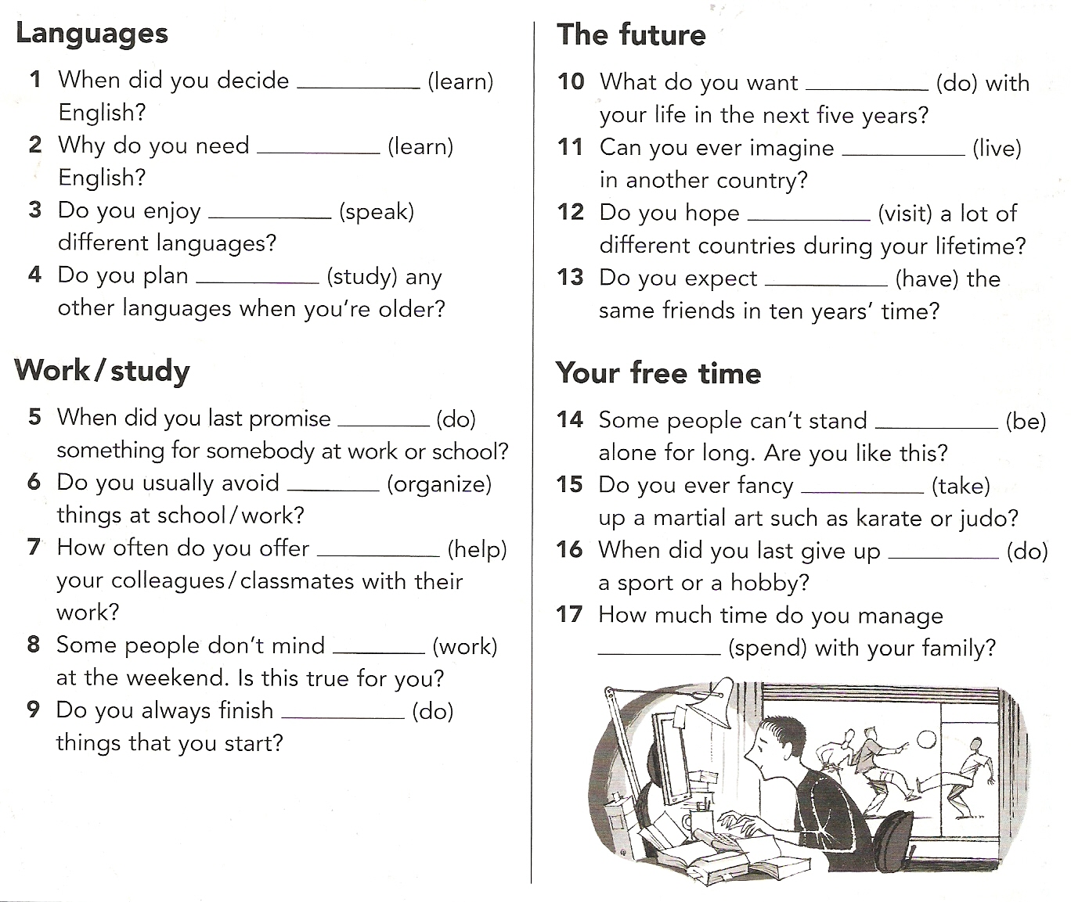

I have always wanted……………………..

I enjoy………………………………..

I plan…………….. this year.

I’ve promised………………………

I would like to give up…………………….

I need…………………………… today.