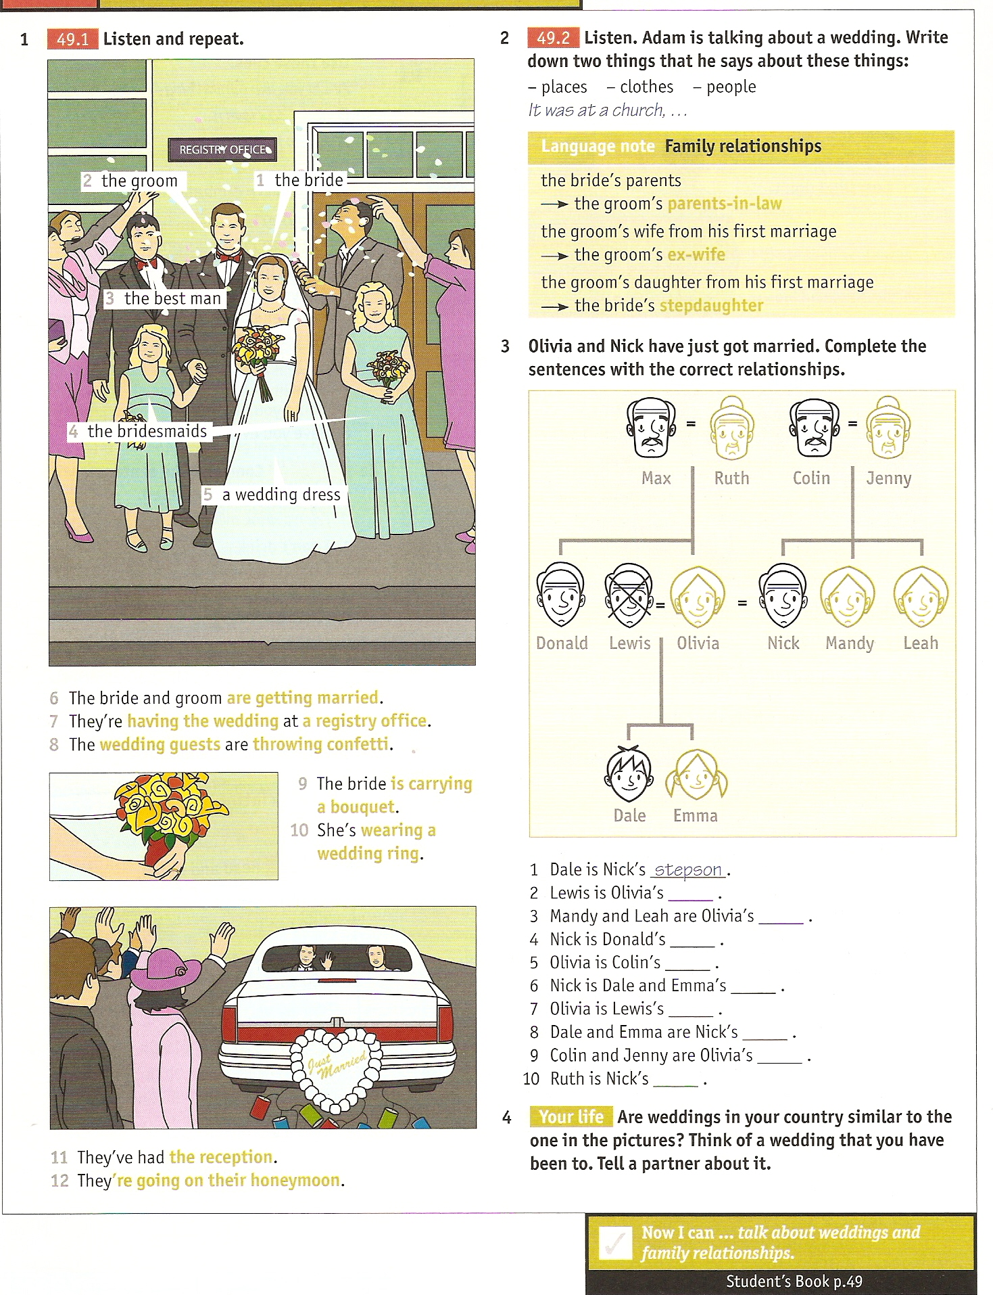
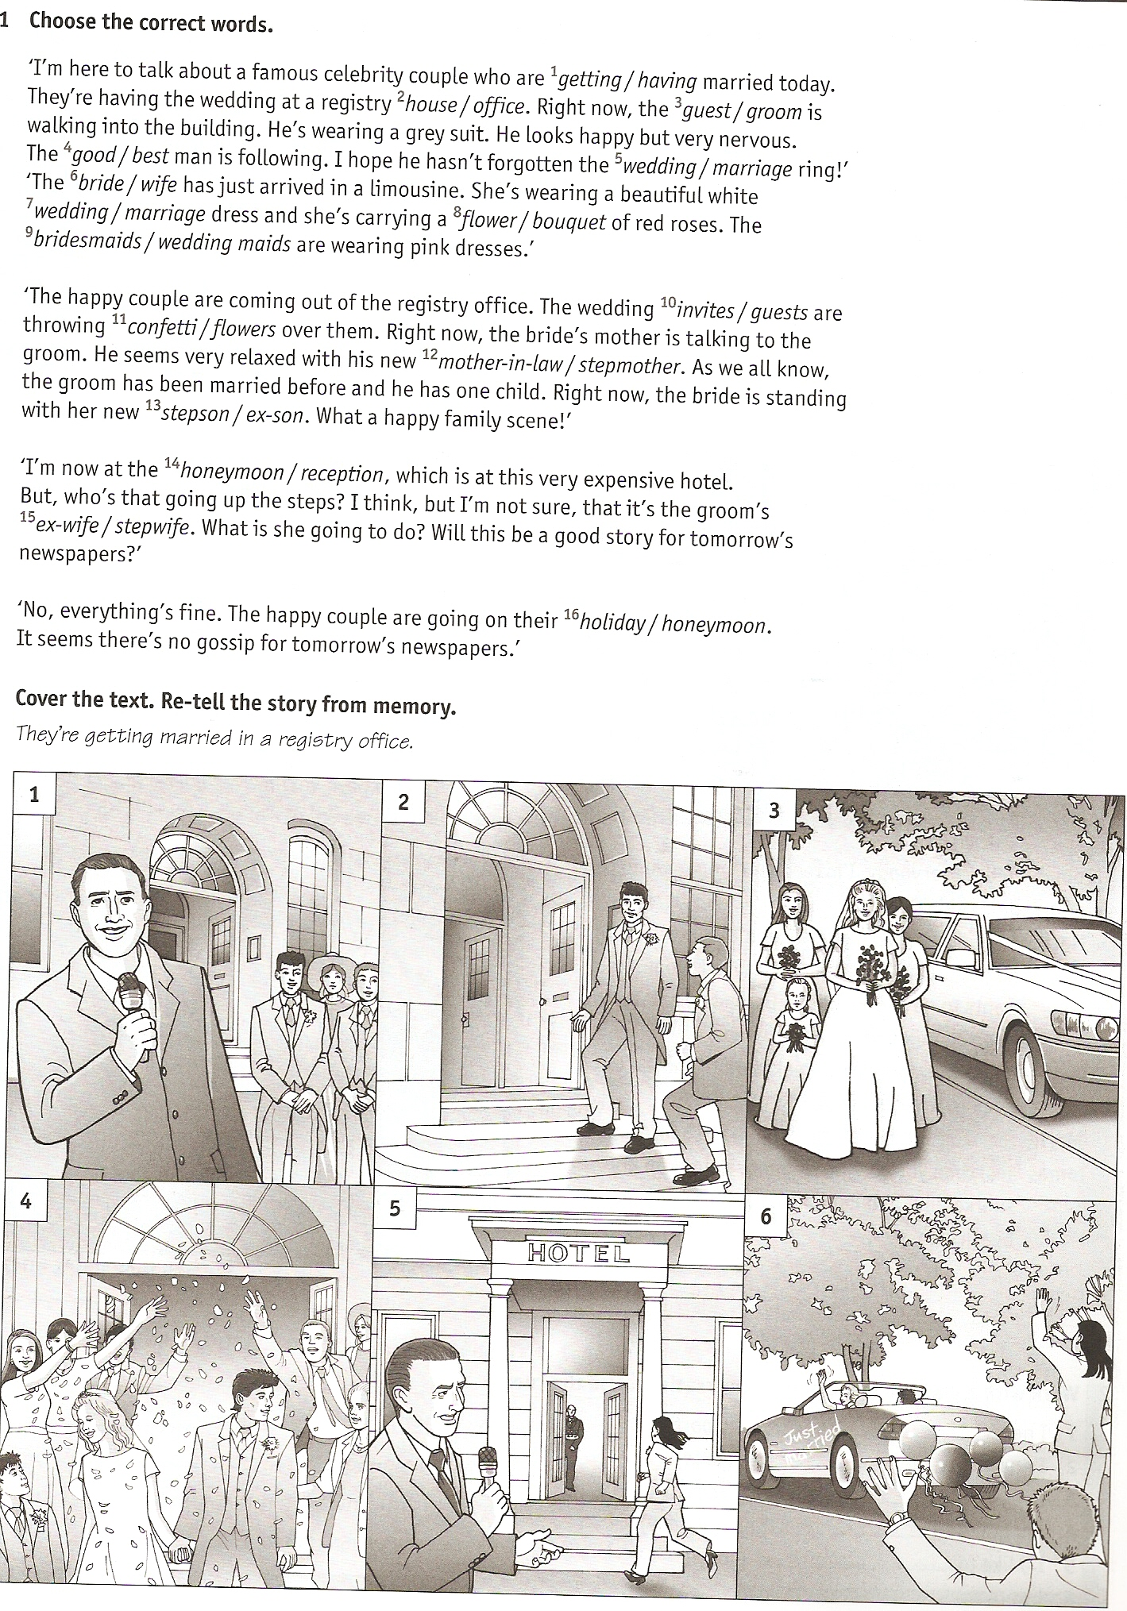
What springs to mind when you hear the word ‘weddings’?
Are weddings important?
What kind of weddings do you think are best?
Do you wish you could go to more weddings?
Why do many people not like weddings?
Do you think it’s easy or difficult to plan your own wedding?
What’s the best and worst wedding you’ve ever been to?
What are the best and worst things about weddings?
Do you think weddings in other countries are better than those in your country?
Do you think your wedding is the happiest day of your life?
What kind of wedding would you like (have liked)?
Which celebrity wedding would you really like to go to?
What do people getting married in your culture promise each other in a wedding?
In your country, do people have to invite people they don’t like to their wedding?
What is the best part of a wedding: the ceremony, the vows, or the reception?
Do you think that one day, weddings will become a thing of the past?
What do you think of alternative weddings such as underwater weddings or weddings on the wing of a flying airplane?
What three adjectives would you use to describe weddings?

