**Welcome to my country**

**Warm up** – **vocabulary**

Define the following words:

castle cave lake dam forest field highway national park flood cathedral monastery

**Finish the sentence**

Czechia is \_\_\_\_\_\_\_\_\_\_\_\_\_\_\_\_\_\_\_\_\_\_\_\_\_\_\_\_\_\_\_\_\_\_\_\_\_\_\_\_\_\_\_\_\_\_\_.

The best thing about my country is \_\_\_\_\_\_\_\_\_\_\_\_\_\_\_\_\_\_\_\_\_\_\_\_\_\_\_\_\_\_\_\_.

I really hate when Czechs \_\_\_\_\_\_\_\_\_\_\_\_\_\_\_\_\_\_\_\_\_\_\_\_\_\_\_\_\_\_\_\_\_\_\_\_\_\_\_\_.

**Basic Facts:**

**Make questions:**

\_\_\_\_\_\_\_\_\_\_\_\_\_\_\_\_\_\_\_\_\_\_\_\_\_\_\_\_\_\_\_\_\_\_\_\_\_\_\_\_\_\_\_\_? – Prague

\_\_\_\_\_\_\_\_\_\_\_\_\_\_\_\_\_\_\_\_\_\_\_\_\_\_\_\_\_\_\_\_\_\_\_\_\_\_\_\_\_\_\_\_? – 78,866 km2

\_\_\_\_\_\_\_\_\_\_\_\_\_\_\_\_\_\_\_\_\_\_\_\_\_\_\_\_\_\_\_\_\_\_\_\_\_\_\_\_\_\_\_\_? – 10,424,926

\_\_\_\_\_\_\_\_\_\_\_\_\_\_\_\_\_\_\_\_\_\_\_\_\_\_\_\_\_\_\_\_\_\_\_\_\_\_\_\_\_\_\_\_? – The Vltava River (433km)

\_\_\_\_\_\_\_\_\_\_\_\_\_\_\_\_\_\_\_\_\_\_\_\_\_\_\_\_\_\_\_\_\_\_\_\_\_\_\_\_\_\_\_\_? – Sněžka (1,603m)

\_\_\_\_\_\_\_\_\_\_\_\_\_\_\_\_\_\_\_\_\_\_\_\_\_\_\_\_\_\_\_\_\_\_\_\_\_\_\_\_\_\_\_\_? – Germany, Poland, Austria, and Slovakia

\_\_\_\_\_\_\_\_\_\_\_\_\_\_\_\_\_\_\_\_\_\_\_\_\_\_\_\_\_\_\_\_\_\_\_\_\_\_\_\_\_\_\_\_? – 2,290km (D 810km, PL 761km, A 466km, SK 251km)

\_\_\_\_\_\_\_\_\_\_\_\_\_\_\_\_\_\_\_\_\_\_\_\_\_\_\_\_\_\_\_\_\_\_\_\_\_\_\_\_\_\_\_\_? – The Baltic Sea (290 km)

\_\_\_\_\_\_\_\_\_\_\_\_\_\_\_\_\_\_\_\_\_\_\_\_\_\_\_\_\_\_\_\_\_\_\_\_\_\_\_\_\_\_\_\_? – Rožmberk 489 ha

\_\_\_\_\_\_\_\_\_\_\_\_\_\_\_\_\_\_\_\_\_\_\_\_\_\_\_\_\_\_\_\_\_\_\_\_\_\_\_\_\_\_\_\_? – Vřídlo in Karlovy Vary (72°C)

\_\_\_\_\_\_\_\_\_\_\_\_\_\_\_\_\_\_\_\_\_\_\_\_\_\_\_\_\_\_\_\_\_\_\_\_\_\_\_\_\_\_\_\_? - +40.2°C

\_\_\_\_\_\_\_\_\_\_\_\_\_\_\_\_\_\_\_\_\_\_\_\_\_\_\_\_\_\_\_\_\_\_\_\_\_\_\_\_\_\_\_\_? - -42.2°C

\_\_\_\_\_\_\_\_\_\_\_\_\_\_\_\_\_\_\_\_\_\_\_\_\_\_\_\_\_\_\_\_\_\_\_\_\_\_\_\_\_\_\_\_? – Jelení most in Písek

**Do you know the people in the pictures? What are they famous for?**

[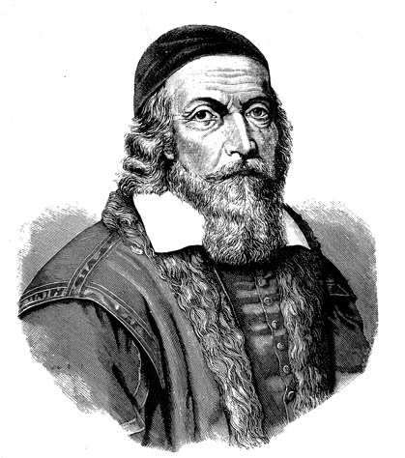](http://upload.wikimedia.org/wikipedia/commons/c/ce/Johan_amos_comenius_1592-1671.jpg)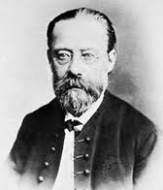[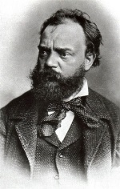](http://upload.wikimedia.org/wikipedia/commons/f/fb/Dvorak1.jpg)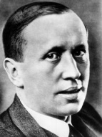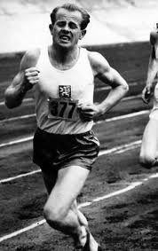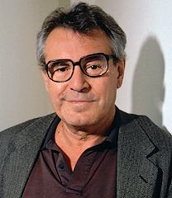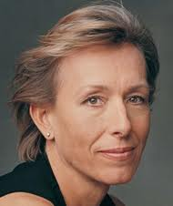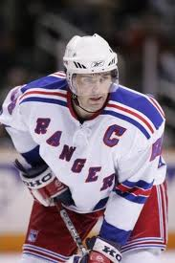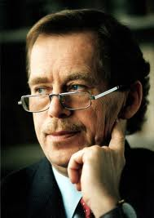****

**Do you know the following brands? What do they represent?**

**** barum_logo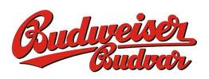

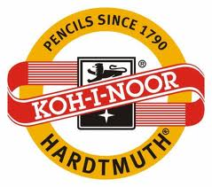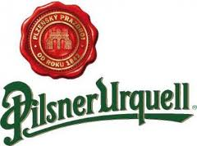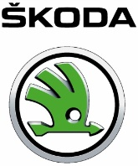

**Reading:**

**When tourists are asked why they are coming to visit the Czech Republic, the answer is: women and beer. It is said that Czechs have the best beer and the most beautiful women in the world. It is also said that we are: peaceful, intelligent, untidy, reserved, greedy, single minded, competitive, disrespectful and that we love culture, black humour and almost everybody here is an intellectual. How do they see us?**

Some men are really exclusive here. Not handsome but they have a great sense of humour and charm. But they are vain and unreasonably self-satisfied. Women are much more different. They are self-confident and they know how to take advantage of their virtues. Sometimes I just have to stop on the street and watch how they disappear in the crowds.  
Czechs love going for a glass of beer and there to discuss everything (politics, sport...). Family is a very important issue. If you get the opportunity to be a part of their world, it is a wonderful experience. Czechs love enjoying their lives. They have a good sense of humour and smile a lot.

***a German***

Every woman is called Sarka and has such long legs. In general most Czechs are good looking. But why do they have the tendency (especially men) to lose their appearance very soon? Maybe it is because of knedlo-vepro-zelo, beer and smoking.  
***an American***

Women are beautiful. But sometimes they are trying too hard to look the same as those models in magazines. Then I feel like I'm meeting "the same faces" all the time. Men don't care a lot about themselves. However younger generation is changing this slowly.  
Czechs had a lot of famous writers, composers and scientists. They are intelligent. That is true about individuals, not about society as a whole.   
At first I thought Czechs were cold. Today I think it is because of their reserved behaviour towards strangers. At home or among their friends they act so much differently, they are friendly and sincere. Inside their families they are bound tightly together and they help each other a lot more than in Japan. That is what I admire. And they talk with each other a lot, sometimes even too long.

***a Japanese***

I don't think Czechs have a good taste. However there are big differences between the young and older generation. Old people are too conservative; they were influenced by the communism more than they can accept. Young people are open to new things; you can see their joy that they have a choice.  
What is very typical for this nation is their discretion. They don't solve problems right away. They sit down and talk about it or let the time to solve it.

***a Pole***

I think a lot of people here have a problem with their freedom. To understand it, to enjoy it. They are not used to it and they always look for some restrictions. They don't want to be responsible for their lives. They need "someone" who will take care of them, who will tell them what to do.  
Most of the people have a good taste, not the rich people. They became rich too quickly and they don't know how to spend their money. Czechs are reserved. They don't like to say their opinion in the public. What I really hate is their aggression while driving. They don't have respect for each other. And one more thing, Czech men don't know how to flirt - they take everything too seriously.

***an Austrian***

What are famous inventions invented in our country?

Is our country famous for any food or recipes?

Do many tourists come to our country?

What is your favourite holiday destination in our country?

What are the most important phone numbers?

What are we good at?

What is a must-see in our country?

What products are we famous for?

What are the most important driving regulations? (alcohol, seat belts, headlights, communication devices, etc.)

**Tips and advice for visitors to our country:**

You should …

You shouldn’t …

It is a good idea …

Remember to …

It is necessary …

Don’t forget to …

…