- Form nouns from verbs and adjectives. Then choose three nouns and make three sentences. Notes:
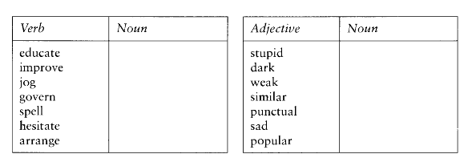
- Complete the article with nouns made out of adjectives or verbs.
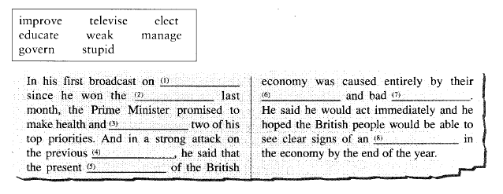
- Write down the name of the person who does these things.

