**YOUNG AND OLD ROOMMATES**

**Write down definitions:**

roommate –

retiree/ pensioner –

nursing home –

stranger –

Have you ever shared your room, flat, or house with a stranger?

What do you know about **coach surfing**?

What are advantages and disadvantages of strangers living together?

Who is the oldest person in your family? How often do you see him or her?

What is difficult about being old?

What are some advantages of being a **pensioner** = a **retiree**?

How could this be improved?

Do you think the way in which older people are treated has got better or worse in your lifetime?

What are some disadvantages of being young, e.g. university students, young people trying to be independent from their parents?

Have you ever been to a **nursing home / retirement home**? Can you imagine living there?

**Video:** Young and old roommates.

What do you think of the programme?

What are the potential advantages and disadvantages?

Can you imagine living in a nursing home during your university studies?

Would you like to live in a home like this when you retire?

**READING: Old and young people living together**

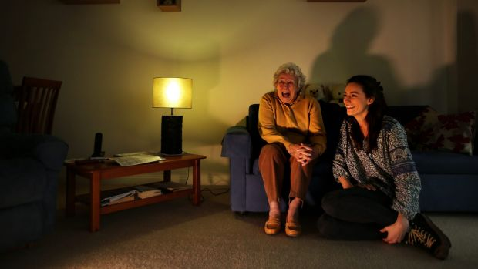Nora Pasfield is 84 and likes romance novels and the occasional microwave meal. Annabelle McClean, 23, prefers art books and fresh food. Nora likes watching *Miss Marple* mysteries but hates reality TV cooking shows. Annabelle is a *MasterChef* fan. They both enjoy *Downton Abbey.* And soup.

They're a strange couple, separated by several generations. But a proposed "homeshare" scheme in Sydney can soon bring seniors and 20-somethings together under the same roof. Young people will live with older residents for free or at reduced rent, in return for spending up to 10 hours a week doing housework, such as cooking, cleaning or shopping.

The proposed model is designed to help young people find affordable housing, while helping older people stay at home rather than in a nursing home. "People of my age like their independence. But having someone else in your life and your home could be a relief," says Nora, who has lived alone since her husband, Arthur, died in 2014.

She needs help changing lightbulbs or turning the mattress and likes the idea of living with someone young. They sit side-by-side on Nora's sofa to discuss the scheme. "Most women my age enjoy younger people around. And a lot of people would love to have someone else to talk to," Nora says.

Annabelle, who rents a converted garage next to Nora’s small flat, works four jobs while studying arts but is having problems to save for her own home. "At weekends I go to the occasional party but part of living with somebody else, whether they're 20 or 84, is having a level of respect – so when you come home you don't make a huge noise," she says.

"If you can have 50 older Australians able to stay in their homes for longer and 50 younger people able to live closer to work and school, and not have rental stress, you would make a massive impact in the community," says Youth Action's managing director. "Applicants will be checked and have to agree on housework and living costs."

There's a common misconception that younger people and older people don't have anything in common but they do. Nora and Annabelle were both born in London. They both like travelling, early mornings and living by the beach. "I think we've got pretty similar points of view," Nora says.

Which scheme do you like better and why?

Now when you know more about it, can you imagine you could do it?