**YOUNG AND OLD ROOMMATES**

Have you ever shared your room, flat, or house with a stranger?

What is your opinion on coach surfing?

What are advantages and disadvantages of strangers living together?

What are some advantages of being a **pensioner** = a **retiree**?

Do you think elderly people are treated well in your society?

What is difficult about being old? What type of problems do elderly people face in modern society? How could this be improved?

What are some disadvantages of being young, e.g. university students, young people trying to be independent from their parents?

Have you ever been to a **nursing home**? Can you imagine living there?

**Video:** Young and old roommates.

What do you think of the program?

What are the potential advantages and disadvantages?

Would you have liked/like to spend your university years living in a retirement home?

Would you like to live in a home like this when you retire?

**READING: Old and young people living together under proposed 'homeshare' trial**

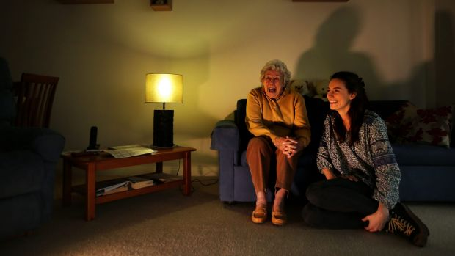Nora Pasfield is 84 and likes romance novels and the occasional microwave meal. Annabelle McClean, 23, prefers art books and fresh food. Nora likes watching *Miss Marple* mysteries but hates reality TV cooking shows. Annabelle is a *MasterChef* fan. They both enjoy *Downton Abbey.* And soup.

They're an odd couple, separated by several generations. But a proposed "homeshare" scheme in Sydney could soon bring seniors and 20-somethings together under the same roof. Young lodgers would live with older residents for free or at reduced rent, in return for spending up to 10 hours a week completing chores, such as cooking, cleaning or shopping.

The proposed model is designed to assist young people find affordable housing, while helping older people remain at home rather than in an aged care facility. "The age group I am in like their independence. But having someone else in your life and your home could be a relief," says Nora, who has lived alone since her husband, Arthur, died in 2014.

She needs help changing lightbulbs or turning the mattress and likes the idea of living with someone young. They sit side-by-side on Nora's powder-blue settee to discuss the scheme. "Most women my age enjoy younger people around. And a lot of people would love to have someone else to talk to," Nora says. "I would like for them to be my friend, I wouldn't like to look on them as a lodger."

Her house rules would include no late-night parties in the living room. But she wouldn't set a curfew. "Let's face it, we've all been young some time."

Annabelle, who rents a converted garage next to Nora’s small flat, works four jobs while studying arts but is struggling to save for her own home. "On weekends I go to the occasional party but part of living with somebody else, whether they're 20 or 84, is having a level of respect – so when you come home you don't make a huge noise," she says.

"It's a big age difference but it's not forever. You can help someone else out while you're also helping yourself out, and being able to save and study."

"If you can have 50 older Australians able to stay in their homes for longer and 50 younger people able to live closer to work and school, and not have rental stress, you would make a massive impact in the community," says Youth Action's managing director Katie Acheson who brought the idea from the Netherlands.

Applicants would have background checks and have to agree on chores and living costs, before being approved for any trial, she says. "There's a common misconception that younger people and older people don't have anything in common but they do."

Nora and Annabelle were both born in London, though some 61 years adrift. They both like travelling, early mornings and living by the beach. "I think we've got pretty similar points of view," Nora says.

Which scheme do you like better and why?

Now when you know more about it, can you imagine you could do it?

If you had been at university, would you have done it?

And what about when you get old?

***Food for thoughts***

*A 72-year old woman gives birth*

*A 72-year-old woman from Amritsar, India is celebrating the birth of her first child. Daljinder Kaur and her husband Mohinder Singh Gill, 79, posed for photos for the Indian press last week, proudly holding their healthy baby boy Arman. The couple had been trying to have a baby for decades, without success. They had been under a lot of pressure during that time to start a family. While most people would have accepted their fate and resigned themselves to a life without children, Daljinder and Mohinder persisted in their dream for a child. Daljinder started attending the National Fertility and Test Tube Baby Centre for IVF treatment in 2013 and successfully became pregnant last year.*

*Specialists at the fertility clinic initially had reservations about offering Daljinder treatment because of her age. Dr Anurag Bishnoi told reporters: "I first tried to avoid the case because she was very weak, but then her medical reports were normal and she was fit to conceive." He added: "Our track record handling IVF in older women has been fairly good, but not everyone is fit to conceive. In her case, she looked visibly frail too, so I had to refer her to a cardiologist to get clearance for the procedure and for a battery of other tests." Meanwhile, Daljinder is over the moon about becoming a mother. She said: "I can live happily now. My life is complete." She is now the oldest woman ever to give birth.*